I 111111111111111111111 lllllllllllllllllllllllllllllllllllllllllllllllllIIIIllllllllll
2018-739819 1/10/2018 11:10 AM PAGE: 1 OF 2 BOOK: 571 PAGE: 431 FEES: $15.00 PK WARRANTY DEED EDA SCHUNK THOMPSON, SHERIDAN COUNTY CLERK

WARRANTY DEED
Peter G. Schoonmaker, a single person, GRANTOR, of Sheridan County, State of Wyoming, for and in consideration of Ten and More Dollars ($10.00), in hand paid, receipt whereof is hereby acknowledged, does hereby CONVEY and WARRANT to the GRANTEES, Max Simonson and Bailey Simonson, husband and wife, as tenants
by the entirety, whose address is V>.o. oCi?J- '?ne,J)'M- w 'i 'ffO I , the
following described real estate, situate in Sheridan County and' State of Wyoming,
hereby releasing and waiving all rights under and by virtue of the homestead exemption laws of the State, to-wit:

SEE EXHIBIT "A" ATTACHED HERETO

Together with all improvements situate thereon and all appurtenances thereunto appertaining or belonging.

Subject to all exceptions, reservations, rights-of-way, easements, covenants, restrictions, and rights of record and subject to any state of facts which would be
disclosed by an accurate survey or physical inspection of the premises and subject to building and zoning regulations and city, state and county subdivision laws.
s my hand this / 0 day of ::u..,,.,,7, . 2018.

{ o ;i-/

State of Wyoming County of Sheridan
The foregoing instrument was acknowledged before me by Peter G. Schoonmaker, this
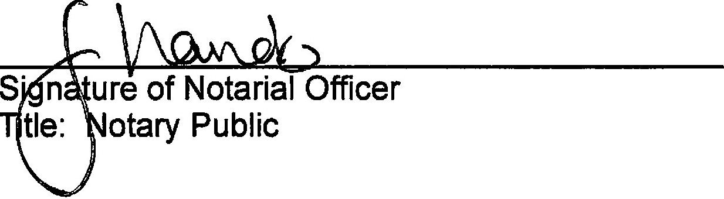
J.Q_ day of .:To.nu<¥'-') , 2018. Witness my hand and official seal.

My Commission Expires: (9 · l 9 · /"t


I IIIIIIII IIII Ill lllll lllll11111111111111111111111111111111111IIIII IIIIII Illllll llll
2018-739819 1/10/2018 11:10 AM PAGE: 2 OF 2 BOOK: 571 PAGE: 432 FEES: $15.00 PK WARRANTY DEED EDA SCHUNK THOMPSON, SHERIDAN COUNTY CLERK

EXHIBIT"A" LEGAL DESCRIPTION

A tract of land situated in the NW1/4SW1/4 of Section 16 and the NE1/4SE1/4 of Section 17, Township 55 North, Range 83 West, 6th P.M., Sheridan County, Wyoming; as shown as Tract No. 4 on EXHIBIT "B" of Warranty Deed recorded in Book 486 of Deeds, Page 671 in the Office of the Sheridan County Clerk, said Tract No. 4 being more particularly described as follows:

Commencing at the southwest corner of said NW1/4SW1/4 of Section 16, said point being the POINT OF BEGINNING of said Tract No. 4; thence N89°43'24"W,
935.09 feet along the south line of said NE1/4SE1/4 of Section 17 to a point; thence N03°29'49"E, 1012.10 feet to a point; thence N74°47'19"E, 317.99 feet to a point; thence, through a curve to the right having a radius of 400.00 feet, a central angle of 16°20'01", an arc length of 114.03 feet, a chord bearing of N82°57'20"E, and a chord length of 113.65 feet to a point; thence S88°52'40"E, 143.18 feet to a point; thence, through a curve to the right having a radius of 400.00 feet, a central angle of 17°34'53", an arc length of 122.74 feet, a chord bearing of S80°05'13"E, and a chord length of 122.26 feet to a point; thence S71°17'47"E, 130.84 feet to a point; thence, through a curve to the right having a radius of 400.00 feet, a central angle of 23°17'30", an arc length of 162.61 feet, a chord bearing of S59°39'02"E, and a chord length of 161.49 feet to a point; thence S48°00'17"E, 438.51 feet to a point; thence, through a curve to the left having a radius of 250.00 feet, a central angle of 39°12'23", an arc length of 171.07 feet, a chord bearing of S67°36'28"E, and a chord length of 167.75 feet to a point; thence S38°49'08"E, 792.42 feet to a point, said point lying on the south line of said NW1/4SW1/4 of Section 16; thence N89°27'15"W, 1050.95 feet to the POINT OF BEGINNING of said tract (said tract purported to contain 35.84 acres of land, more or less).

Basis of Bearings is Wyoming Coordinate System NAD 1983, East Central Zone. Distances are surface.

NO. 2018-739819 WARRANTY DEED
EDA SCHUNK THOMPSON, SHERIDAN COUNTY CLERK
SCTIA
SHERIDAN WY 82801

